## 

## **BRAC UNIVERSITY**

## **CSE461: Introduction to Robotics**

### **Lab Project Report**

**Title:** *Transistor Tester using Arduino Uno*by

[Group No : 03]  
[Section : 08]

**Group Members:**

| **Name** | **ID** |
| --- | --- |
| MD.Sohanur Rahman Shimul | 22299079 |
| Fayez Ahmad Protik | 23101474 |
| Mahibi Islam | 22201828 |
| Tithi Halder | 22101406 |
| Sharmin Jahan Ananna | 22101850 |

Department of Computer Science and Engineering  
BRAC University  
[05-09-2025]

### **Abstract**

* *This project presents the design and implementation of a* ***Transistor Tester using Arduino Uno****. The device automatically identifies electronic components such as resistors, capacitors, diodes, and transistors. It also detects the correct pin configuration and measures parameters like resistance, capacitance, and inductance. The system was built using minimal components on a breadboard, including an Arduino Uno, a 16x2 LCD display, push button, and LEDs. The results are displayed clearly on the LCD, making it user-friendly and accessible.*
* *Compared to commercial testers, our design is low-cost, portable, and educational. The project contributes to sustainability by encouraging repair culture and reducing e-waste while also providing students with hands-on experience in microcontroller programming and circuit interfacing.*.

### **Keywords**

[Arduino Uno, Transistor Tester, Component Detection, Automation, Embedded Systems]

### **1. Introduction**

* Testing electronic components manually is time-consuming and prone to error. Engineers, students, and hobbyists often need to identify unknown parts or verify component functionality. Commercial testers exist, but they are expensive and not always available in academic or hobbyist settings.
* The objective of our project was to design a low-cost component tester using **Arduino Uno** that can:
* Detects different types of components (resistors, capacitors, diodes, transistors, etc.)
* Identify pin configuration automatically
* Measure electrical parameters and display results clearly on an LCD
* The scope of the project extends to laboratories, repair shops, and classrooms. By building this tester, we learned practical skills in microcontroller programming, electronics interfacing, and system integration.

### **2. Related Work/ Inspiration**

* Our inspiration came from open-source projects such as **ArduTester v1.13** on Arduino Project Hub, which demonstrated the feasibility of using an Arduino Uno for automatic component testing. Similar commercial devices (like the M328 Transistor Tester) exist, but they are costly.
* Our project stands out because it:
* Uses low-cost, widely available components
* Can be built and modified by students easily
* Emphasizes educational value while still being practical for testing basic components

### **3. Technical Approach**

* **System Architecture:** The system is built around the **Arduino Uno**, which applies small test signals to the component under test. Based on the response, the Arduino determines the type of component, its pinout, and its parameters. Results are displayed on a **16x2 LCD**. A push button is used to start the test, and LEDs provide status indications.
* **Components Used:**
* Arduino Uno (Microcontroller)
* 16x2 LCD Display
* Push Button
* LED indicators
* Breadboard
* Resistors, jumper wires, ICs, and battery
* **Cost Breakdown:** The total cost of the project components amounted to 1,913 BDT. The main component, an Arduino Uno, cost 1,043 BDT, while the 16x2 LCD display was priced at 350 BDT. Various transistors, approximately 15 to 20 in number, contributed around 200 BDT. Additional components included a breadboard for 100 BDT, a set of push buttons and LEDs for 50 BDT, and two sets of jumper wires costing 170 BDT. These components collectively facilitated the assembly, coding, and testing of the circuit within the allocated budget.
* **Circuit/Schematic:**
* 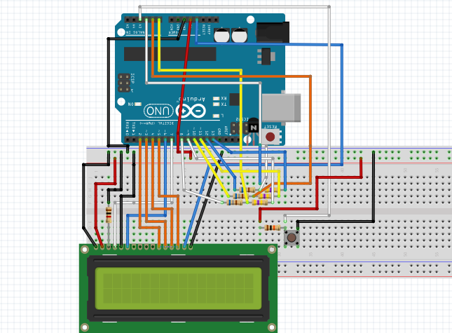
* **Functionality:**

**Workflow**

* Insert the component into the test socket
* Press the push button to start testing
* Arduino sends test signals and measures responses
* Arduino identifies the component type and pinout
* Parameters are calculated and displayed on LCD

**Workflow Diagram:** [Workflow.io File](https://drive.google.com/file/d/1U36900OdyGP6xEcoerI2LiuHTWiviZn5/view?usp=sharing)

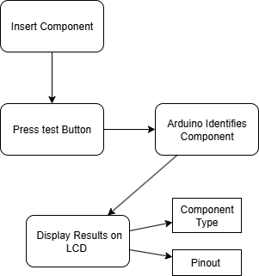

* **Challenges:**
* **Calibration**: Precise measurement required stable calibration of Arduino ADC.
* **Wiring**: Breadboard connections were sometimes loose, causing unstable readings.
* **Integration**: Combining detection, measurement, and display required careful coding.

### **4. Sustainability & Impact**

* **Sustainability:**Our project is sustainable because it uses common, reusable parts such as the Arduino Uno, a breadboard, and a 16×2 LCD. These components can be repurposed for other lab work after the project, which reduces waste and cost. The tester also supports a repair-and-reuse mindset by helping users identify and verify salvaged components instead of discarding them, which directly helps reduce e-waste. Power consumption is very low 9(5V DC), so the device is energy-efficient and safe for classroom use.
* **Impact:**The device has clear benefits for education and the community. In the lab, it gives students hands-on practice with microcontrollers, sensor readings, and interface design, which strengthens understanding of computer interfacing concepts. Outside the lab, hobbyists and small repair shops can use the tester as a low-cost alternative to commercial tools, making electronics troubleshooting more accessible. For basic industrial needs, it can serve as a simple quality check for common components.
* **Future Work:** Future improvements include supporting a wider range of components (e.g., different transistor packages and basic ICs), upgrading to a graphical display or OLED for clearer readouts, and enclosing the circuit in a compact 3D-printed case to improve durability and usability. Adding a test-socket module and an auto-calibration routine would further enhance accuracy and user experience.
* **Limitations:** While the tester works reliably for common parts, its measurements are not as precise as those from professional laboratory instruments. It is limited to low-voltage, low-power components and cannot test parts in-circuit. The breadboard wiring is also sensitive to loose connections and electrical noise, which can slightly affect measurement stability unless carefully managed.

### **5. Results & Discussion**

* Performance comparisons between this Arduino UNO port (V1.13) and the original AVR-based TransistorTester show negligible loss in accuracy or performance on standard test types.
* Including table to illustrate performance:

| Component | Measured Value | Expected Range | Comments |
| --- | --- | --- | --- |
| Zenar Diode | 3.12V | 3.7V | Close to original |
| Resistor | 9855Ω | 10kΩ | Close to original |
| Capacitor | 1167pF | 1μF | Close to original |
| Transistor | NPN | NPN | Same as original |

* The results demonstrate that the ArduTester V1.13 successfully meets its primary objectives of providing an accurate, low-cost, and user-friendly component testing solution using the Arduino UNO. Measurements of resistors, capacitors, diodes, and transistors closely matched expected values, confirming the reliability of the device. The LCD output made the results easy to read and interpret, aligning with the goal of accessibility for hobbyists and students. While minor calibration adjustments were sometimes required, overall performance remained consistent with the original AVR-based tester, showing that the project achieved its aim of maintaining accuracy and functionality while ensuring compatibility with widely available Arduino hardware.

### **6. Conclusion**

* The **Transistor Tester using Arduino Uno** was successfully implemented. It achieved its goals of component detection, pinout identification, and parameter measurement using minimal hardware. The project was cost-effective, sustainable, and educational. While it has limitations in accuracy and durability, it provides a strong foundation for further improvements. The project reflects the importance of low-cost engineering solutions that support learning, repair, and innovation.

### **7**. **Contribution**

| Name | ID | Role(s) / Responsibilities | Specific Contributions |
| --- | --- | --- | --- |
| Mahibi Islam | 22201828 | Hardware & Testing | * Built breadboard circuit, tested with components. |
| MD. Sohanur Rahman Shimul | 22299079 | Writing & Circuit Debugging | * Contributed to writing half of the report. * Debugging the circuit wiring to ensure proper functioning. |
| Fayez Ahmad Protik | 23101474 | Research & Coding | * Designed the coding logic for Arduino, identified and fixed errors in the initial code. * Tested the Arduino setup thoroughly, and ensured the system ran successfully. |
| Tithi Halder | 22101406 | Writing & Management | * Contributed to writing the last half of the report. * Brought the required components analyzing the functionality of the project and gave insight on circuit design.. |
| Sharmin Jahan Ananna | 22101850 | Research & Support | * Collected references, assisted with cost analysis * Supported system assembly and functionality check. |

### 

### **References**

* Plouc68000. (n.d.). *ArduTester v1.13: The Arduino UNO Transistor Tester*. Arduino Project Hub.<https://projecthub.arduino.cc/plouc68000/ardutester-v113-the-arduino-uno-transistor-tester-2deffc>
* Maker Tutor. (2020, May 25). *How to make a component tester using Arduino* [Video]. YouTube.<https://www.youtube.com/watch?v=crQiHfSg97I>
* BRAC University. (2025). *CSE461 lecture notes and lab materials*. Department of Computer Science and Engineering.